Appendix A
Activity/Event | Tackling Construction Skills Shortage: Stevens Story
Date | May 2021
Beneficiaries | Local Unemployed Residents
Delivery Partner | Costain, Procure Plus and CITB
Framework Theme | Inclusive Workforce
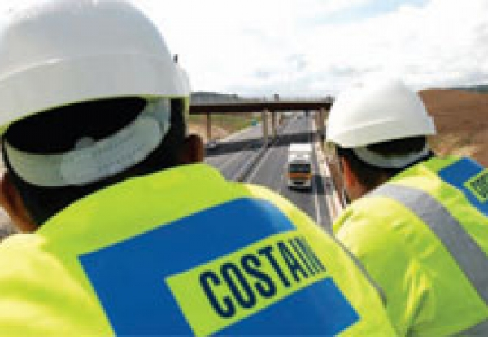
Meet Steven
Steven is currently working on the Preston Western Distributor and East-West Link Road with Costain as a Vehicle Banksman.
Prior to this opportunity, Steven hadn’t worked for coming up to 12 years having had to leave work to become a full time Dad, following his partner suddenly and unexpectedly becoming very poorly following the birth of their son.
About the On-Site Experience Commission
Fully funded by CITB, the On-Site Experience Commission aims to increase the number of people trained in construction supported by the opportunity to gain actual experience (and subsequently – employment) as a way of continuing to tackle the skill shortage across the UK spanning the next 3 years. Procure Plus has been awarded the commission in Lancashire,
Steven's Story
Following a marital breakdown, Steven’s circumstance deteriorated during which he found himself living in a homeless shelter for 2 months prior to securing himself a flat in late 2020 – which was a key turning point in Steven getting his life back on track.
In January, Steven visited his local community support for a food parcel and it was during this meet that Progress Futures asked Steven what other support they could provide for him. It was that conversation that sign posted Steven to Procure Plus and we immediately signed him up to do his Health & Safety L1 and CSCS touchscreen test.
Meanwhile, Procure Plus were fully engaged with Costain who were keen to recruit from the local communities as part of their social value commitment. Steven was identified as an ideal candidate for one of their Vehicle Banksman and received additional training to secure his NPORS certificate. Following 2 weeks of paid on site experience, Steven was offered a full-time role on the Preston Western Distributor project.
What difference has this opportunity made to you?
"It’s made a massive difference and has opened a whole new door of opportunities for me. Me and my son are already able to do more things as a family together. I have the means to take us places, to do things and to enjoy life a bit more. It means I can now plan for the future more than I ever could. One of the things I’ll be doing for sure is finally learning how to drive with the hope of hopefully owning my own car – which will open up more opportunities again. It’s given me much needed financial security, a sense of purpose which has been a huge boost for my overall wellbeing."
Feedback from Steven's Foreman
“Steven genuinely works hard, is always on time, is enthusiastic and forward thinking - which is perfect for me. His level of effort is 100%. He sets a great example to people around him - and he’s got a cracking good sense of humour which is an added bonus!”
Dan Grant Foreman, PSI Global

